KWAME NKRUMAH UNIVERSITY OF SCIENCE AND TECHNOLOGY
FACULTY OF ALLIED HEALTH SCIENCE
DEPARTMENT OF MEDICAL DIAGNOSTICS


MODULATORY EFFECT OF THE ACE I/D POLYMORPHISM ON CARDIOMETABOLIC RISK FACTORS IN HYPERTENSIVE AND NORMOTENSIVE ADULTS AT TAMALE TEACHING HOSPITAL

STUDENTS | INDEX NUMBER
KELVIN ENAM GAMELI | 2077922
LORDINA OKAI BAABO | 2076122

SUPERVISORS: PROFESSOR CHRISTIAN OBIRIKORANG

MARCH, 2026

DEDICATION
We dedicate this work to Jesus Christ for the grace, mercy, favour, and protection He has bestowed on us and to our mothers for their support throughout this journey.

ACKNOWLEDGEMENT
Our ultimate gratitude goes to God Almighty for His mercies, wisdom, the gift of life, and strength throughout this research journey. This work would not have been possible without His grace and mercy. We would like to express our sincerest gratitude to our supervisor, Prof. Christian Obirikorang, and mentor, Ms Rasheda Nyamekye, for their guidance, patience, immense support, and encouragement at every stage of this work.

TABLE OF CONTENTS
DEDICATION i
ACKNOWLEDGEMENT ii
LIST OF FIGURES vii
LIST OF TABLES viii
LIST OF ABBREVIATIONS ix
CHAPTER 1 1
1.0 BACKGROUND 1
1.1 PROBLEM STATEMENT 2
1.2 JUSTIFICATION 2
1.3 AIM 3
1.3.1 SPECIFIC OBJECTIVES 3
CHAPTER 2 4
2.1 DEFINITION AND CLASSIFICATION OF CARDIOMETABOLIC RISK FACTORS 4
2.1.1 DEFINITION AND OVERVIEW 4
2.1.2 HYPERTENSION 4
2.1.3 DYSLIPIDEMIA 5
2.1.4 GLYCAEMIC REGULATION AND DIABETES 6
2.1.5 ELECTROLYTE BALANCE IN CARDIOMETABOLIC REGULATION 7
2.1.6 CLASSIFICATION OF RISK FACTORS 8
2.2 GLOBAL PREVALENCE AND TRENDS 8
2.2.1 CURRENT GLOBAL BURDEN 8
2.2.2 FUTURE PROJECTIONS TO 2050 9
2.2.3 REGIONAL VARIATIONS 9
2.4 THE ACE I/D POLYMORPHISM AND ITS FUNCTIONAL SIGNIFICANCE 9
2.4.1 THE RENIN-ANGIOTENSIN SYSTEM AND ACE 9
2.4.2 THE INSERTION AND DELETION (I/D) POLYMORPHISM 11
2.4.3 FUNCTIONAL CONSEQUENCES OF THE POLYMORPHISM 11
2.4.4 RELEVANCE TO GHANA 12
2.5 ACE I/D POLYMORPHISM AND CARDIOMETABOLIC RISK FACTORS 13
2.5.1 ACE I/D AND LIPID PROFILE 13
2.5.2 ACE I/D AND GLYCAEMIC CONTROL 13
2.5.3 ACE I/D AND ELECTROLYTE REGULATION 14
2.5.4 ACE I/D AND BLOOD PRESSURE 14
2.5.5 GENE-ENVIRONMENT INTERACTIONS 15
2.6 CARDIOMETABOLIC RISK IN GHANA 15
2.6.1 NATIONAL BURDEN 15
2.6.2 NORTHERN GHANA BURDEN 15
2.6.3 HEALTHCARE ACCESS AND AWARENESS 16
2.6.4 GENETIC STUDIES IN GHANA 16
2.7 SUMMARY AND IDENTIFICATION OF RESEARCH GAP 17
2.7.1 SUMMARY OF KEY FINDINGS 17
CHAPTER 3 18
3.1 INTRODUCTION 18
3.2 STUDY DESIGN 18
3.3 STUDY AREA / SETTING 18
3.4 STUDY POPULATION 19
3.5 INCLUSION AND EXCLUSION CRITERIA 19
3.5.1 INCLUSION CRITERIA 19
3.5.2 EXCLUSION CRITERIA 20
3.6 SAMPLE SIZE DETERMINATION 21
3.7 SAMPLING TECHNIQUE 21
3.8 DATA COLLECTION METHODS 22
3.8.1 CLINICAL AND ANTHROPOMETRIC MEASUREMENTS 22
3.8.2 BLOOD SAMPLE COLLECTION 22
3.9 LABORATORY / EXPERIMENTAL METHODS 23
3.9.1 BIOCHEMICAL ASSAYS 23
3.9.2 ELECTROLYTE DETERMINATION 23
3.9.3 DNA EXTRACTION 24
3.9.4 PCR AMPLIFICATION OF ACE I/D GENE 24
3.9.5 GEL ELECTROPHORESIS 25
3.10 DATA ANALYSIS 26
3.11 ETHICAL CONSIDERATIONS 26

LIST OF FIGURES
Figure 2.1: A map of study site 6
Figure 3.1: A map of study site 19
Figure 3.2: An image of nanodrop machine 24
Figure 3.3: Setup for gel electrophoresis 25

LIST OF TABLES
Table 3.1 Primers used in PCR Reactions 25

LIST OF ABBREVIATIONS
CVD | cardiovascular disease
ASCVD | Atherosclerotic cardiovascular disease
TC | Total Cholesterol
TG | Triglycerides
VLDL-C | Very Low-Density Lipoprotein Cholesterol
HbA1c | Glycated Haemoglobin
LDL-C | Low-Density Lipoprotein Cholesterol
HDL-C | High-Density Lipoprotein Cholesterol
ACE | Angiotensin-Converting Enzyme
ALT | Alanine Aminotransferase
ACE I/D | Angiotensin-Converting Enzyme Insertion/Deletion Polymorphism
RAAS | Renin Angiotensin Aldosterone System
LMICs | Low- and Middle-Income Countries
WHO | World Health Organisation
BP | Blood Pressure
SBP | Systolic Blood Pressure
DBP | Diastolic Blood Pressure
BMI | Body Mass Index
WC | Waist Circumference
DNA | Deoxyribonucleic Acid
PCR | Polymerase Chain Reaction
ELISA | Enzyme-Linked Immunosorbent Assay
SDS | Sodium Dodecyl Sulphate
bp | Base Pair
Na+ | Sodium
K+ | Potassium
Cl- | Chloride
T2DM | Type-2 Diabetes Mellitus
CI | Confidence Interval
OR | Odds Ratio
SD | Standard Deviation

CHAPTER 1
INTRODUCTION

1.0 BACKGROUND
Cardiovascular disease (CVD) refers to a group of disorders that affect the heart and blood vessels, including coronary heart disease, stroke, and hypertension (World Health Organization, 2025a). It is the leading cause of death worldwide, accounting for about 19.8 million deaths as of 2022 (World Health Organization, 2025a). This is projected to rise to 35.6 million annually by 2050. The major factors associated with the increase in cardiovascular diseases are attributed to urbanisation, changes in diets, low physical activity, and an ageing population (Chong et al., 2024).
This trend is particularly pronounced in Sub-Saharan Africa, where rapid urbanisation and lifestyle changes are driving a sharp increase in CVD burden (Alhuneafat et al., 2024). In Ghana, national surveys have found that 55.4% of adults suffer from hypertension, 37.3% suffer from dyslipidaemia, and 21.1% are obese (J. Li et al., 2020). This situation is especially severe in northern Ghana, where access to health care is poor, health awareness is low, and the prevalence of hypertension is 27.9%, while low HDL-cholesterol exceeds 60% (Agongo et al., 2022; Nonterah et al., 2024). The Tamale Teaching Hospital is a major referral centre for this region, making it an ideal setting to investigate whether hypertension status modifies the effect of the ACE I/D polymorphism on cardiometabolic risk factors (Surazu & K. Korsah, 2023).
The renin-angiotensin-aldosterone system (RAAS) is critical for regulating blood pressure, electrolytes, and cardiovascular homeostasis (Bonney et al., 2024). A common polymorphism in the angiotensin-converting enzyme (ACE) gene, known as the insertion/deletion (I/D) polymorphism, has been linked to serum ACE concentrations (AL-Eitan et al., 2024). Individuals with the DD genotype have approximately twice the serum ACE levels as II carriers, while ID heterozygotes show intermediate levels (Rezaei et al., 2022).
The DD polymorphism has been linked to high blood pressure, adverse lipid profile, obesity, and susceptibility to type 2 diabetes mellitus in several meta-analyses (Luo, 2024). Most of these studies, however, were conducted in European or Asian populations, limiting their generalizability to African settings (Gomera et al., 2026). The prevalence of the D allele in Ghana is 54% (Duah-Quashie et al., 2024), yet, no study has examined whether hypertension status alters this association.

1.1 PROBLEM STATEMENT
Despite the high frequency of the D allele in Ghana (54%), no study has examined whether hypertension status modifies the established links between the ACE I/D polymorphism and cardiometabolic risk factors. Existing research in Ghana has focused only on single outcomes such as blood pressure, without testing this interaction.

1.2 JUSTIFICATION
Understanding whether hypertension modifies the genetic effect of the ACE I/D polymorphism is important because it could help identify a subgroup of patients at a high risk of CVD. If the DD genotype confers greater cardiometabolic risk in hypertensives than in normotensives, then hypertensive individuals carrying the D allele could be prioritised for earlier screening and more intensive preventive interventions. This study will provide the first Ghana-specific data on the modulatory role of the ACE I/D polymorphism. This will enhance understanding of genetic susceptibility to cardiometabolic diseases and inform future risk stratification strategies in this population.

1.3 AIM
This study aims to investigate the modulatory effect of the ACE I/D polymorphism on cardiometabolic risk factors in hypertensive and normotensive Ghanaian adults at Tamale Teaching Hospital.

1.3.1 SPECIFIC OBJECTIVES
- To determine the distribution of ACE I/D genotypes and allele frequencies among hypertensives and normotensives.
- To compare mean serum ACE concentrations across ACE I/D genotypes.
- To compare lipid profile, HbA1c, and electrolyte levels (Na, K, Cl) across ACE genotype groups
- To assess whether hypertension status modifies the association between ACE genotype and cardiometabolic risk factors.
- To evaluate the odds of dyslipidaemia, dysglycemia, and clustered abnormalities associated with the DD genotype.

CHAPTER 2
LITERATURE REVIEW

2.1 DEFINITION AND CLASSIFICATION OF CARDIOMETABOLIC RISK FACTORS

2.1.1 DEFINITION AND OVERVIEW
Cardiometabolic risk factors are a group of interconnected conditions that damage cardiac and vascular structures, increasing the possibility of developing cardiovascular diseases and other metabolic disorders. They include central obesity, impaired glucose regulation, high blood pressure, dyslipidaemia, and fluid and electrolyte imbalances (Chakraborty et al., 2023; W. Li et al., 2026; Quirino-Vela et al., 2025). Understanding how genetic polymorphisms affect these risk factors is essential to identifying high-risk individuals and developing targeted interventions.

2.1.2 HYPERTENSION
Hypertension, characterised by consistently elevated systolic (≥140 mmHg) and diastolic blood pressure (≥90 mmHg), is a major cardiometabolic risk factor (Chakraborty et al., 2023; World Health Organization, 2025b). It is often referred to as a “silent killer” because it exhibits no major clinical symptoms, but if left untreated, it can lead to fatal issues (World Health Organization, 2025b). Globally, an estimated 1.4 billion adults aged 30-79 were living with hypertension in 2024, yet fewer than 1 in 5 (320 million) had the condition adequately controlled (World Health Organization, 2025b).
It causes a number of dysregulated physiological systems, resulting in increased cardiac output and blood volume. An important regulator of hypertension is the renin-angiotensin-aldosterone system (RAAS) (Chakraborty et al., 2023). Renin is released from the kidneys and stimulates the conversion of angiotensinogen to angiotensin I. The angiotensin-converting enzyme (ACE) present in the lungs converts Angiotensin I to Angiotensin II. Angiotensin II then induces vascular constriction and peripheral resistance, stimulates aldosterone secretion, which promotes sodium and water retention, and also activates sympathetic activity (Chakraborty et al., 2023).
Hypertension, more often than not, exists with other cardiometabolic risk factors, including obesity and insulin resistance, which synergistically promote vascular damage. The modifiable risk factors for hypertension include a high-salt diet, physical inactivity, and alcohol use, while the non-modifiable risk factors include age, genetics, and other persistent metabolic diseases (Quirino-Vela et al., 2025).

2.1.3 DYSLIPIDEMIA
Dyslipidaemia is another major cardiometabolic risk factor. It is characterised by elevated levels of low-density lipoproteins, triglycerides, and total cholesterol, and reduced levels of high-density lipoproteins. It mostly results from diet, genetic disorders, and obesity (Agongo et al., 2018; Obirikorang et al., 2020).
Elevated levels of LDL cholesterol, particularly small dense LDL particles, promote the development and progression of atherosclerosis. These particles readily penetrate the arterial wall and are highly susceptible to oxidative modification, resulting in the accumulation of cholesterol, inflammatory cells, and vascular smooth muscle cells within the arterial wall. This process leads to the formation of fatty streaks that gradually develop into fibrous atherosclerotic plaques. Plaque rupture may subsequently trigger thrombus formation, leading to acute cardiovascular events such as myocardial infarction and stroke. Furthermore, dyslipidaemia promotes endothelial dysfunction through increased oxidative stress and inflammation, further exacerbating the risk of cardiovascular disease (Chakraborty et al., 2023).
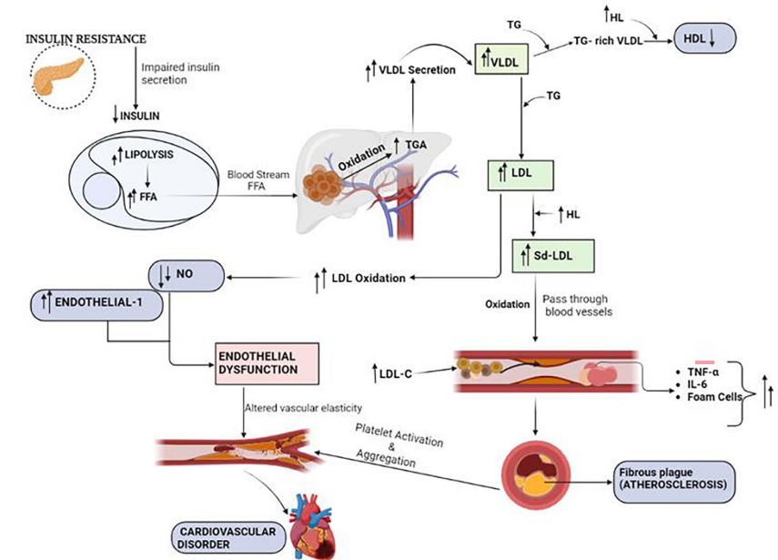
Figure 2.1: A map of study site

2.1.4 GLYCAEMIC REGULATION AND DIABETES
Diabetes affected about 11.11% of the global adult population, accounting for nearly 589 million adults in 2024. This is expected to increase to 12.96%, corresponding to 853 million people by 2050 (Genitsaridi et al., 2026). Glycaemic regulation refers to the body’s ability to maintain normal blood glucose levels. This is done through a feedback loop where the pancreatic islets release insulin to lower high glucose, and glucagon to raise low glucose by controlling liver glucose output and cell uptake (Amin & Salman, 2025; Quirino-Vela et al., 2025).
Hyperglycaemia occurs when blood glucose levels rise above normal, and this is a characteristic of diabetes. According to the American Diabetes Association Professional Practice Committee for Diabetes et al. (2026), diabetes mellitus is diagnosed when fasting plasma glucose is ≥ 7.0mmol/L or when HbA1c is ≥ 6.5%. Prediabetes is a state of impaired glucose regulation, defined as HbA1c between 5.7% and 6.4% or fasting plasma glucose level ≥ 5.6mmol/L (American Diabetes Association Professional Practice Committee for Diabetes et al., 2026). Chronic hyperglycaemia activates several biochemical pathways, including the polyol pathway, advanced glycation end-product formation, oxidative stress, and the hexosamine biosynthetic pathway. These processes simultaneously promote excessive oxidative damage, endothelial dysfunction, inflammation, and adverse cardiac remodelling, consequently increasing cardiovascular damage (Hussain, 2025).
Variations in HbA1c have been shown to increase the risk of CVDs. A meta-analysis performed in 2025 found that higher HbA1c variability was associated with an increased risk of cardiovascular events (HR = 1.32, 95% CI: 1.18-1.49) (Wu et al., 2025). In this study, HbA1c was measured as a marker of long-term glycaemic control to assess its relationship with cardiovascular diseases.

2.1.5 ELECTROLYTE BALANCE IN CARDIOMETABOLIC REGULATION
Electrolytes are electrically charged minerals found in the body. They play very important roles in cardiovascular and metabolic function. Sodium and potassium are responsible for volume and osmotic regulation. Chloride is another important electrolyte that helps to maintain fluid and acid-base balance. High sodium intake increases blood volume by drawing water into the bloodstream, which raises the pressure inside blood vessels. Sodium also damages the endothelial lining of vessels, promoting stiffness and reducing their ability to relax. Together, these effects contribute to the development and progression of hypertension and cardiovascular disease, as opposed to high potassium levels, which lower blood pressure and reduce the risk of stroke (Ma et al., 2022; O’Donnell et al., 2019). Low chloride levels have been linked to poor cardiovascular outcomes (Georgopoulou et al., 2025). Because these electrolytes influence blood pressure and heart function, measuring them will help determine whether their levels are associated with the ACE I/D genotype and cardiometabolic risk.

2.1.6 CLASSIFICATION OF RISK FACTORS
Cardiometabolic risk factors are commonly classified into 3 categories based on their cause-and-effect pathways and how their interventions occur. They are behavioural, biomedical, and non-modifiable (fixed) risk factors. Behavioural risk factors are lifestyle choices that individuals can change. These include diet, smoking, and exercise (Olié, Grave, et al., 2024). Biomedical risk factors are physiological risk factors that directly increase the risk of CVDs, such as hypertension, obesity, and dyslipidaemia. Non-modifiable risk factors, as their name implies, are those that cannot be modified or changed and include age, sex, and genetics (Olié, Gabet, et al., 2024). This classification is important because it enables us to identify both the underlying causes of CVD and the appropriate preventive or treatment strategies.

2.2 GLOBAL PREVALENCE AND TRENDS

2.2.1 CURRENT GLOBAL BURDEN
The leading cause of global CVD burden as of 2023 was ischemic heart disease, followed by intracerebral haemorrhage, ischemic stroke, and hypertensive heart disease (Stark et al., 2025). CVD deaths have increased significantly from 13.1 million in 1990 to 19.2 million in 2023, with prevalence rates having increased from 311 to 626 million cases (Naeem et al., 2026). Five modifiable risk factors (hypertension, hyperlipidaemia, abnormal weight, diabetes, and smoking) account for approximately 50% of the global CVD burden. However, individuals with none of these risk factors at age 50 live significantly longer, that is, 13.3 years longer for women and 10.6 years longer for men, as compared to those with all five risk factors (Global Cardiovascular Risk Consortium, 2025).

2.2.2 FUTURE PROJECTIONS TO 2050
By 2050, global CVD mortality is estimated to increase to 35.6 million deaths annually, with prevalence rates at 1.14 billion global cases. This increase is largely due to population growth, aging, and improved access to care in low and middle-income countries (Naeem et al., 2026). High systolic blood pressure is projected to remain the single largest contributor to CVD burden, followed by high LDL cholesterol, and then a high BMI (Chong et al., 2024).

2.2.3 REGIONAL VARIATIONS
The burden of CVDs and their risk factors differ based on demographics and geographical region (Victor et al., 2025). The GBD 2023 collaborators used age-standardized rates, which removed the effects of different age structures to compare countries equally. They found that CVD death rates are highest in low and low-middle-income countries and lowest in high-income countries after accounting for differences in population age (Stark et al., 2025). The predominant type of CVD also varies by region. Ischemic heart disease is more common in high-income countries, whereas stroke is predominant in Africa, Southeast Asia, and the Western Pacific (Victor et al., 2025).

2.4 THE ACE I/D POLYMORPHISM AND ITS FUNCTIONAL SIGNIFICANCE

2.4.1 THE RENIN-ANGIOTENSIN SYSTEM AND ACE
The renin-angiotensin-aldosterone system (RAAS) is a hormonal cascade that is a central regulator of cardiovascular, renal, and fluid homeostasis (Cosarderelioglu & Abadir, 2025). It controls fluid and electrolyte balance as well as blood pressure. A key enzyme in this system is the Angiotensin-Converting Enzyme (ACE), which converts the inactive peptide, angiotensin I, to angiotensin II (Bayraktutan, 2025). Angiotensin II is widely known for its role in cardiovascular disease, acting as a potent vasoconstrictor that raises blood pressure and contributes to target organ damage (Morat et al., 2025).
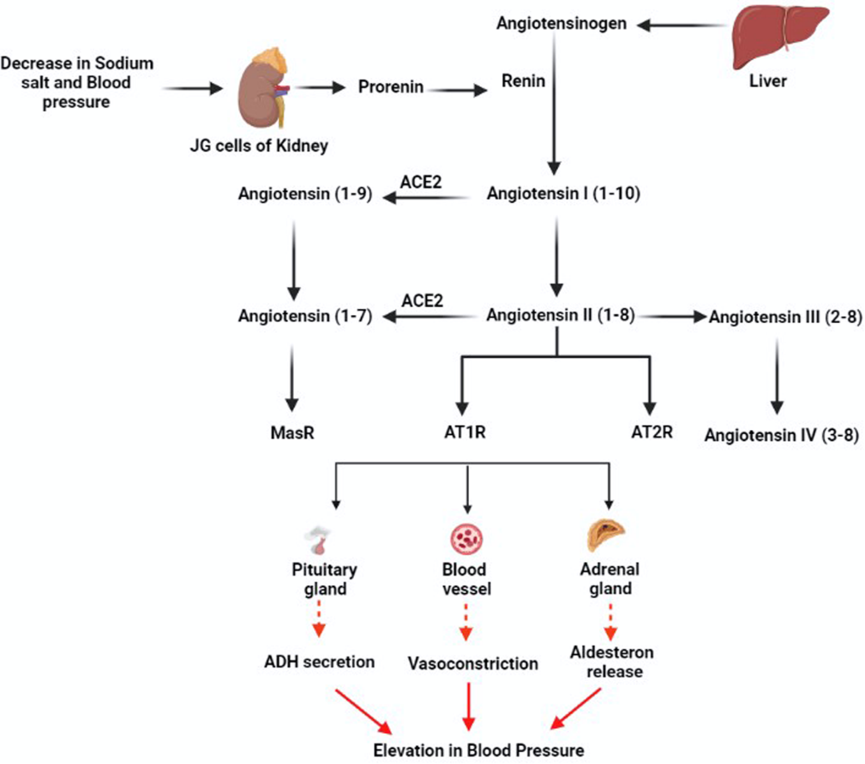
Angiotensin II, once produced, exerts its effects by binding to its type 1 (AT1R) or type 2 (AT2R) receptors. The activation of AT1R promotes vasoconstriction, oxidative stress, endothelial dysfunction, peripheral vascular resistance, and smooth muscle cell proliferation and migration (Bayraktutan, 2025). The pro-inflammatory angiotensin II/AT1R axis also contributes to vasoconstriction, oxidative stress, inflammation, and fibrosis (Cosarderelioglu & Abadir, 2025). The RAAS and immune system interact through various mechanisms in hypertension, which include inflammation, immune cell infiltration, oxidative stress, and endothelial dysfunction (Kasal & Schiffrin, 2012).

2.4.2 THE INSERTION AND DELETION (I/D) POLYMORPHISM
The angiotensin-converting enzyme (ACE) gene is located on chromosome 17q35 with 26 exons and introns, and it is an important gene in cardiovascular research. A key polymorphism in this gene is the Insertion/Deletion variant also known as rs1799752 (Rezaei et al., 2022). This polymorphism is characterized by the presence (insertion, I) or absence (deletion, D) of a 287-base pair (bp) Alu repetitive sequence in the 16th intron of the ACE (Dutta et al., 2024; Rezaei et al., 2022). Due to this, individuals can have one of three possible genotypes which are the II (homozygous for the insertion), ID (heterozygous), or DD (homozygous for the deletion) genotypes (Kiconco et al., 2024; Rezaei et al., 2022).
This genetic variation is associated with differences in circulating ACE levels (Rezaei et al., 2022). The DD genotype is associated with a higher ACE activity, while the II genotype is associated with lower activity of the enzyme (Rezaei et al., 2022). This polymorphism continues to be explored in various health conditions, seen in recent studies investigating its role in male infertility and obesity in different populations (Bhan et al., 2025; Saleh et al., 2025).

2.4.3 FUNCTIONAL CONSEQUENCES OF THE POLYMORPHISM
The ACE I/D polymorphism has significant functional consequences, primarily through its effect on circulating ACE levels. The I/D polymorphism accounts for most of the variability in ACE activity (Rezaei et al., 2022). Individuals with the DD genotype have a higher ACE activity, while those with the II genotype have a lower activity, and those with the heterozygous ID genotype show intermediate levels (Rezaei et al., 2022).
Studies have reported that the DD genotype is associated with approximately higher plasma ACE levels compared to the II genotype (Mohammedi et al., 2024). This variation in ACE activity has been shown to influence an individual’s susceptibility to various diseases, including COVID-19 (Fajar et al., 2024).
For our study, the DD genotype has also been linked to adverse cardiometabolic effects. A 2024 meta-analysis involving about 94,000 participants found that carriers of the DD genotype had significantly higher levels of total cholesterol, LDL-cholesterol and triglycerides, systolic and diastolic blood pressures, body mass index, and waist circumference compared to II/ID carriers (Luo, 2024).

2.4.4 RELEVANCE TO GHANA
In the Ghanaian population, the D allele is the most common variant. A study of 300 Ghanaians found that 54% of individuals carried the D allele. This represents the first genetic evidence that a significant proportion of Ghanaians possess the D variant (Duah-Quashie et al., 2024). The high prevalence rate also suggests that a significant portion of the Ghanaian population may be at increased risk of CVDs.
Hence, our study aims to investigate whether the association between ACE I/D polymorphism and cardiometabolic risk factors differs between hypertensive and normotensive adults in Northern Ghana, and whether hypertension status modifies this relationship. Presence of the D allele does not necessarily result to heart problems. Nonetheless, there may be some increased risk of contracting the disease, particularly when combined with conditions like hypertension, high sodium levels, and obesity. It is necessary for one to understand this interaction as it will enable one to know when to conduct early screenings.

2.5 ACE I/D POLYMORPHISM AND CARDIOMETABOLIC RISK FACTORS

2.5.1 ACE I/D AND LIPID PROFILE
A 2024 meta-analysis found that carriers of the DD genotype had significantly higher levels of triglycerides, total cholesterol, and LDL-cholesterol compared to carriers of the II and I/D genotypes (Luo, 2024). However, the relationship may be influenced by gender as a separate study reported that ACE I/D predicted the TG/HDL-C ratio, but the effects of HDL-C and LDL-C were significant only in females(Liu et al., 2024). These findings indicate that the impact of ACE I/D on lipid profiles is not the same across populations or sexes.

2.5.2 ACE I/D AND GLYCAEMIC CONTROL
Studies indicate that the ACE I/D polymorphism influences the risk of developing type 2 diabetes mellitus (T2DM). A 2024 meta-analysis of 15,166 participants found that the D variant was associated with a 14% increased risk of T2DM relative to the I variant (OR 1.14; 95% CI; 1.04-1.24) (Zhou et al., 2009). Another meta-analysis focused on the Middle East and North Africa (MENA) region further confirmed this. They found a significantly increased risk of T2DM susceptibility with the D allele (OR 1.97, 95% CI= 1.33-2.93, p = 0.0007) (El Alami et al., 2022).
The association between the D allele and T2DM risk is shown by its effects on insulin sensitivity and glucose regulation. One study demonstrated that the DD genotype was linked to lower insulin sensitivity and a higher likelihood of impaired glucose tolerance (Bonnet et al., 2008). Moreover, the study found that 2-hour post-load glucose levels were significantly higher in DD individuals compared to II and ID subjects (Bonnet et al., 2008). These findings confirm potential interactions between the renin-angiotensin-aldosterone and glucose metabolism. The ACE I/D is associated with insulin sensitivity and impaired glucose tolerance (Bonnet et al., 2008). This shows that the D allele of the ACE I/D polymorphism is a risk factor for impaired glucose regulation and type 2 diabetes by promoting insulin resistance.

2.5.3 ACE I/D AND ELECTROLYTE REGULATION
The renin-angiotensin-aldosterone system (RAAS) regulates sodium and potassium balance through aldosterone, which promotes sodium retention and potassium excretion (Triebel & Castrop, 2024). One study reported that hypertensive men carrying the D allele had higher serum sodium levels (Pavlyushchik et al., 2017). Dietary sodium intake modifies the association between ACE I/D and blood pressure, indicating a gene-environment interaction. This shows that the ACE genotype may influence how the body handles sodium, which in turn affects cardiovascular risk (Kuznetsova et al., 2004). Therefore, this study will examine whether ACE I/D genotype is associated with serum sodium, potassium, and chloride levels as part of cardiometabolic risk assessment.

2.5.4 ACE I/D AND BLOOD PRESSURE
The association between the ACE I/D polymorphism and blood pressure has been extensively studied. A comprehensive 2025 umbrella review of meta-analyses, identified the ACE I/D variant as one of the top three predictive single nucleotide polymorphisms (SNPs) for hypertension, demonstrating a strong association (Sopori et al., 2025). This finding is supported by a different study which reported that DD genotype carriers had significantly higher systolic and diastolic blood pressure compared to II and I/D carriers (Luo, 2024). These data together confirm that the ACE D allele is associated with higher blood pressure, reinforcing its role as a risk factor for hypertension.

2.5.5 GENE-ENVIRONMENT INTERACTIONS
Gene-environment interactions occur when the effect of a genetic variant on health outcomes is modified by environment or lifestyle factors, or by the presence of another disease state (Goda et al., 2025). A well-documented example is the interaction between the ACE I/D polymorphism and dietary sodium intake. A community-based study demonstrated that a high sodium intake strengthened the association between the ACE I/D variant and blood pressure levels, indicating that the genetic effect is more pronounced in individuals with a high-salt diet (Kuznetsova et al., 2004). Another study from three prospective cohorts found that the adverse effects of greater waist circumference on blood pressure were larger among carriers of the DD genotype compared to those with the II genotype, suggesting that individuals with the D allele are more prone to the impact of excess adiposity (Sun et al., 2018) . These examples show that the impact of the ACE I/D polymorphism is not uniform but depends on the presence of other factors.

2.6 CARDIOMETABOLIC RISK IN GHANA

2.6.1 NATIONAL BURDEN
The burden of cardiometabolic risk factors in Ghana is substantial. A national study conducted in 2016/2017 found that among Ghanaian adults, the prevalence of hypertension was 55.45, dyslipidaemia was 37.3%, and obesity was 21.1% (J. Li et al., 2020).

2.6.2 NORTHERN GHANA BURDEN
The AWI-Gen project has provided the most comprehensive data on cardiometabolic health in Northern Ghana (Agongo et al., 2018; Nonterah et al., 2024). In the Kassena Nankana Districts, the prevalence of hypertension is 27.9% and type 2 diabetes is 3.5% (Nonterah et al., 2024). Obesity is significantly higher among women compared to men (Nonterah et al., 2024). A separate analysis of the same cohort found that the prevalence of low HDL-C, a key indicator of dyslipidaemia, was 60.3% (Agongo et al., 2018).

2.6.3 HEALTHCARE ACCESS AND AWARENESS
Access to primary healthcare in Ghana, particularly in rural areas, is limited (Kushitor et al., 2024). Over 13.3 million people living in rural Ghana lack direct access to primary healthcare, with long distances and a lack of transportation further increasing the issue (Kushitor et al., 2024). Awareness of NCD risk factors is also low, and patients often only seek care when their health has significantly deteriorated (Kushitor et al., 2024). Even when diagnosed, treatment and control rates are poor. For example, one study found that only 35% of individuals with hypertension in Ghana were aware of their condition, and only 6% had their blood pressure under control (Babagoli et al., 2024).

2.6.4 GENETIC STUDIES IN GHANA
A recent study investigated the association between the ACE I/D polymorphism and hypertension in a Ghanaian population. This study, which included 144 participants from the Tamale Central Hospital, found that the DD genotype significantly increased the risk of hypertension (Bonney et al., 2024). While this research establishes a link between the ACE gene and blood pressure, no studies have yet investigated the potential modulatory effect of hypertension status on the relationship between ACE I/D polymorphism and other cardiometabolic risk factors in Ghana.

2.7 SUMMARY AND IDENTIFICATION OF RESEARCH GAP

2.7.1 SUMMARY OF KEY FINDINGS
Cardiometabolic risk factors are more likely to cluster. They pose an elevated risk of cardiovascular diseases and type 2 diabetes. Globally, the burden of CVDs persists, amounting to 19.2 million deaths and 626 million prevalent cases by 2023. The ACE I/D polymorphism is a well-recognised genetic determinant of ACE activity. DD genotype individuals have the highest ACE concentration, followed by ID genotype and carriers, while II carriers possess the lowest concentrations. The D allele has been associated with high blood pressure, unfavourable lipid profile, type 2 diabetes susceptibility, and possible electrolyte imbalance. Gene-environment interactions modify the above associations, implying that the impact of the ACE gene is context-dependent. The prevalence of cardiometabolic risk factors is remarkably high in Ghana. The D allele frequency is considerably higher in the country. While the burden and cardiometabolic risks of the D allele are established, there is no research on whether hypertension status impacts the association between the ACE I/D genotype and cardiometabolic risk factors.

CHAPTER 3
METHODOLOGY

3.1 INTRODUCTION
This chapter emphasises the methods used in conducting this study. It includes how the research was designed, the study population, sampling techniques, data collection, laboratory analytical methods, and statistical data analysis used in the investigation of the modulatory effect on the angiotensin-converting enzyme insertion/deletion polymorphism on cardiometabolic risk factors. This provides a standard operating procedure to ensure that findings from this study are accurate, repeatable, and reproducible.

3.2 STUDY DESIGN
This case-control study investigates the modulatory effect of the angiotensin-converting enzyme insertion/deletion polymorphism on cardiometabolic risk factors among hypertensives and normotensives. This research is aimed at evaluating how the genetic variations in the angiotensin-converting enzyme, i.e., II, ID, and DD, influence cardiometabolic risk factors like blood pressure, lipid profile, glycaemic index, and electrolyte levels in the serum.

3.3 STUDY AREA / SETTING
This study was conducted at the cardiology unit of the Tamale Teaching Hospital, located in the Northern Region of Ghana.

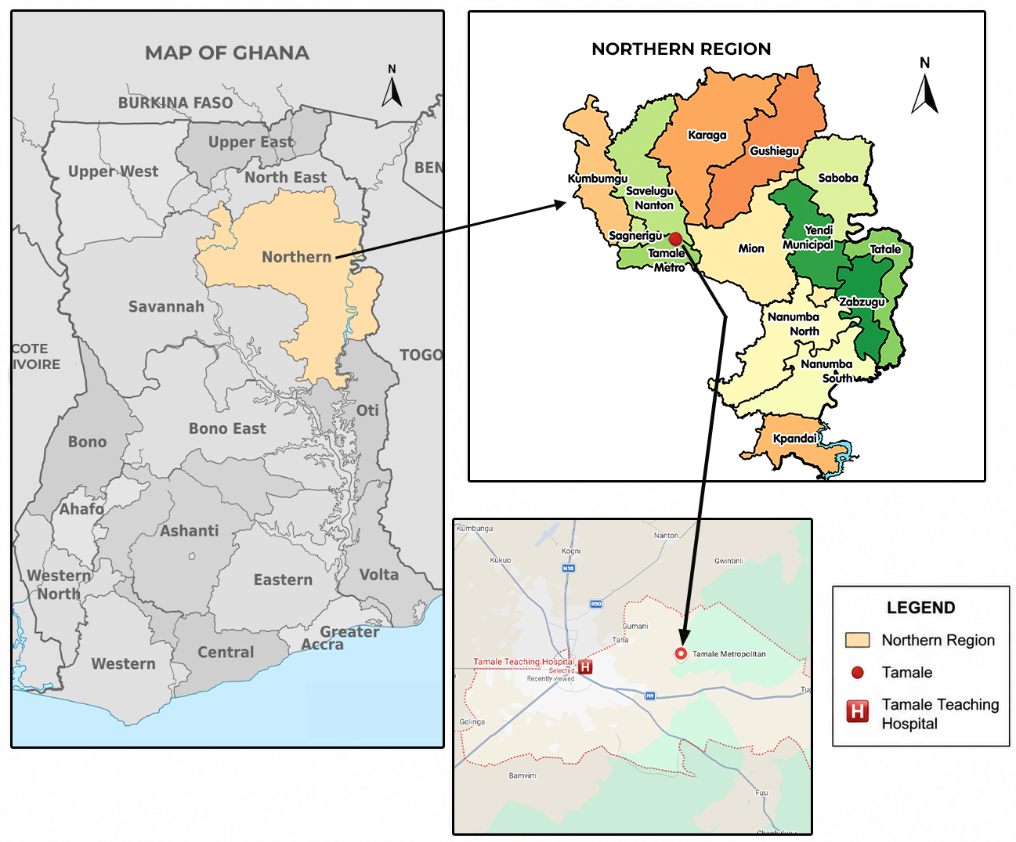
3.4 STUDY POPULATION
Figure 3.1: A map of study site
The study comprised individuals aged 18 to 80 years and also included both hypertensive and normotensive participants from the Tamale Teaching Hospital.

3.5 INCLUSION AND EXCLUSION CRITERIA

3.5.1 INCLUSION CRITERIA
- Cases (Hypertensives): Participants aged 18–80 years were included, as cardiometabolic risk factors are most prevalent in this age range. Hypertensive cases were defined as individuals with systolic blood pressure (BP) ≥140 mmHg and/or diastolic BP ≥90 mmHg, or those currently taking antihypertensive medication, consistent with the Eighth Joint National Committee (JNC‑8) guidelines.
- Controls (Normotensives): Normotensive controls had no prior diagnosis of hypertension, BP <120/80 mmHg, and were not taking antihypertensive, lipid‑lowering, or steroid medications.

3.5.2 EXCLUSION CRITERIA
- People with secondary hypertension (e.g., chronic kidney disease, renal artery stenosis, primary aldosteronism, pheochromocytoma, Cushing syndrome) were excluded to avoid confounding from non‑essential hypertension.
- Patients with recent major cardiovascular events (myocardial infarction or unstable angina within the preceding 3 months) were excluded in the study because acute inflammatory responses and medication changes would alter cardiometabolic biomarkers.
- Patients with severe liver disease (elevated alanine aminotransferase >2× upper normal limit) were also excluded as liver disease directly affects lipid metabolism, which is a primary outcome of this study.
- Patients with severe kidney disease (serum creatinine >2× baseline) were excluded because kidney disease affects blood pressure regulation and electrolyte balance.
- Pregnant or lactating women were excluded due to the significant physiological and hormonal changes that independently alter BP, lipid profiles, and glucose metabolism.
- Patients with incomplete data for any key variable (ACE I/D genotype, lipid profile, HbA1c, electrolytes, or ACE concentration) were also excluded to maintain statistical validity.

3.6 SAMPLE SIZE DETERMINATION
The minimum sample size was determined using a statistical sampling method developed by William G. Cochran.
$$N= \frac{Z^{2}pq}{e^{2}}$$
Where N = required sample size
Z = Z-score
p = estimated prevalence (0.1034)
q = 1 – p = 0.8966
e = margin of error (0.05 for an acceptable margin of error)
$$N= \frac{{(1.96)}^{2}*0.1034*0.8966}{{0.05}^{2}}$$
$$N= \frac{0.3561487431}{0.0025}$$
$$N=142.46$$
$$N≈142$$
Thus, with the prevalence of 10.34% (Doku et al., 2024), q = 0.8966, N = 142 people.
However, 144 participants were recruited: 74 hypertensives and 74 normotensives. This was done to ensure adequate statistical power and account for potential data loss.

3.7 SAMPLING TECHNIQUE
A convenience sampling technique was employed. All individuals who attended the cardiology unit of the Tamale Teaching Hospital during the study period (November 2021 – May 2022) and who met the inclusion criteria were invited to participate. Recruitment was conducted on randomly selected weekdays, and every consecutive eligible patient was approached to minimise selection bias. Standardised data collection protocols were applied uniformly to all participants.

3.8 DATA COLLECTION METHODS

3.8.1 CLINICAL AND ANTHROPOMETRIC MEASUREMENTS
Clinical and anthropometric measurements were taken using standard operating procedures. Sociodemographic and lifestyle information was collected using a questionnaire (WHO Step questionnaire for chronic diseases) and subsequent medical records review. These included age, sex, marital status, educational level, occupation, smoking history, alcohol consumption, and physical activity. Anthropometric measurements included height and weight, BMI (calculated as the quotient of weight in kilograms and the square of height in meters (kg/m2)). This was categorised as underweight (BMI < 18.5), normal (BMI < 25), overweight (BMI ≥ 25), or obese (BMI ≥ 30). Other clinical parameters, like systolic and diastolic blood pressure, were measured using a validated sphygmomanometer at the midpoint of the left arm in a seated position with arm support after each patient had rested for at least 5 minutes. Two blood pressure readings were collected at a minimum time interval of 5 minutes, with the average taken as the true value. Heart rates were also recorded accordingly.

3.8.2 BLOOD SAMPLE COLLECTION
A volume of 5ml of venous blood was drawn from the study participants under aseptic conditions for biochemical and genetic studies. The blood sample taken was then dispensed into both gel separator tubes and K3EDTA anticoagulant tubes for biochemical and molecular analyses, respectively. The K3EDTA blood sample was frozen at -20°C for DNA extraction. The serum was separated by centrifugation of the blood sample at 1000xg for 15 minutes, then aliquoted into cryotubes for biochemical investigations. The remaining serum was stored under appropriate conditions for potential re-analysis.

3.9 LABORATORY / EXPERIMENTAL METHODS

3.9.1 BIOCHEMICAL ASSAYS
Biochemical parameters were measured using an automated chemistry analyser (Konelab 60i, Thermo Scientific, Finland) following documented standard operating procedures. The analyses measured included fasting plasma glucose, HbA1c, total cholesterol, VLDL-C, LDL-C, HDL-C, triglycerides, serum creatinine, and aldosterone levels. Serum ACE levels were estimated using a commercially available solid-phase sandwich enzyme-linked immunosorbent assay (ELISA) kit (DRG International, Inc., USA). All quantifications were performed following the manufacturer’s protocol, and absorbance was read at a wavelength of 450 nm using a microplate reader. The concentrations were reported as ng/L.

3.9.2 ELECTROLYTE DETERMINATION
Concentrations of plasma electrolytes were measured using the Konelab 60i Thermo Scientific autoanalyzer (Thermo Scientific, Finland). The plasma concentrations measured included potassium (K+), sodium (Na+), and chloride (Cl-). These measurements were carried out due to their relevance in the assessment of cardiometabolic health, considering their involvement in fluid homeostasis, blood pressure, and overall cardiovascular function.

3.9.3 DNA EXTRACTION
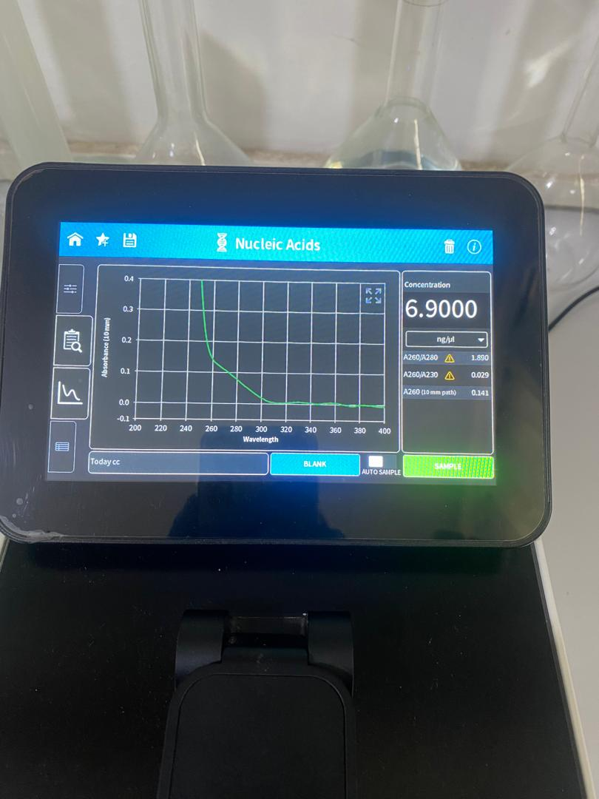
Genomic DNA was extracted from whole blood using a standard salting-out protocol (Sakyi et al., 2017). DNA concentration and purity (A260/280, A260/230) were assessed using a NanoDrop spectrophotometer.
Figure 3.2: An image of nanodrop machine

3.9.4 PCR AMPLIFICATION OF ACE I/D GENE
The ACE I/D polymorphism was genotyped by PCR using primers flanking the 287-bp Alu repeat sequence in intron 16 of the ACE gene (Rezaei et al., 2022). Each 25 µL PCR reaction contained 2 µL of genomic DNA template, 12.5 µL of master mix (containing Taq DNA polymerase, dNTPs, MgCl₂, and reaction buffer), 1 µL each of forward and reverse primers, and 8.5 µL of nuclease‑free water. PCR amplification was performed under the following conditions: initial denaturation at 94°C for 5 minutes; 35 cycles of denaturation at 94°C for 30 seconds, annealing at 58°C for 45 seconds, and extension at 72°C for 60 seconds; and a final extension at 72°C for 10 minutes. A negative control (no template) was included in each PCR run to monitor for contamination.
Table 3.1 Primers used in PCR Reactions
Polymorphism | Primer sequence | Amplicon size(bp)
I/D
Forward | 5’-CTGGAAGAGACCACTCCCATCCTTTCT’-3 | DD | 190
Reverse | 5’GATGTGGCCATCACATTCGTCAGAT3’ | II | 490
 |  | ID | 490 + 190

3.9.5 GEL ELECTROPHORESIS
PCR products were separated by electrophoresis on a 2% agarose gel, stained with ethidium bromide, and visualised under UV light.


Genotypes were assigned as II (490 bp), DD (190 bp), or ID (both bands).
Figure 3.3: Setup for gel electrophoresis

3.10 DATA ANALYSIS
Data were collected, cleaned, verified, and then exported to Statistical Package for the Social Sciences (IBM SPSS Statistics for Windows, Version 27.0.1; IBM Corp., Armonk, NY, USA) for analysis.
Continuous variables were expressed as mean ± standard deviation and compared using the independent samples t-test. Categorical data were also represented using frequencies and percentages and analysed using Fisher’s Exact Test. Logistic regression analysis was used to evaluate the association between ACE gene polymorphism and hypertension status, and the results were reported as odds ratios (ORs) and corresponding 95% confidence intervals (CIs).

3.11 ETHICAL CONSIDERATIONS
Ethical approval was received from the Research Committee of the Tamale Teaching Hospital. Participation was completely voluntary, and participants were recruited into the study after their written informed consent was obtained.
The study participants were made aware of their rights as participants within the research process, and they had the right to discontinue their participation in the study at any time without facing any consequences whatsoever. Steps were taken to guarantee the anonymity and confidentiality of all data collected to enable the study participants to decide whether to be a part of the study.

